BOOTSTRAP

Font style and sizes

<!DOCTYPE html>

<html lang="en">

<head>

    <meta charset="UTF-8">

    <meta name="viewport" content="width=device-width, initial-scale=1.0">

    <title>Document</title>

    <link href="https://cdn.jsdelivr.net/npm/bootstrap@5.3.3/dist/css/bootstrap.min.css" rel="stylesheet"

    integrity="sha384-QWTKZyjpPEjISv5WaRU9OFeRpok6YctnYmDr5pNlyT2bRjXh0JMhjY6hW+ALEwIH" crossorigin="anonymous">

</head>

<body>

    <script src="https://cdn.jsdelivr.net/npm/bootstrap@5.3.3/dist/js/bootstrap.bundle.min.js"

integrity="sha384-YvpcrYf0tY3lHB60NNkmXc5s9fDVZLESaAA55NDzOxhy9GkcIdslK1eN7N6jIeHz" crossorigin="anonymous"></script>

<!--heading tags-->

<h1>Bootstrap 5 tutorial</h1>

<h2>this is an h2</h2>

<h3>this is an h3</h3>

<h2 class="h3">this is an h2 tag with the h3 class</h2>

<!--display tags-->

<h1 class="display-1">display 1 heading</h1>

<h1 class="display-4">display 1 heading</h1>

<!--lead text and alignment-->

<p>sachintha lakshan</p>

<p class="lead">lakshan sachintha munasinghe</p>

<h3 class="lead text-center">bhashitha pinsara</h3>

<p class="lead text-end">vishmi nethsara munasinghe</p>

<!--text decorations and font weight-->

<p class="text-decoration-underline">this is undreline text</p>

<p class="text-decoration-line-through">this is line thought text</p>

<p class="fw-bold">this is bold text</p>

<small>lakshan</small>

<!--text colors-->

<p class="text-primary">theme primary colour</p>

<p class="text-secondary">theme secondary colour</p>

<p class="text-info">theme info colour</p>

<p class="text-warning">theme warning colour</p>

<p class="">theme warning colour</p>

<p class="">theme danger colour</p>

<p class="">theme danger colour</p>

</body>

</html>

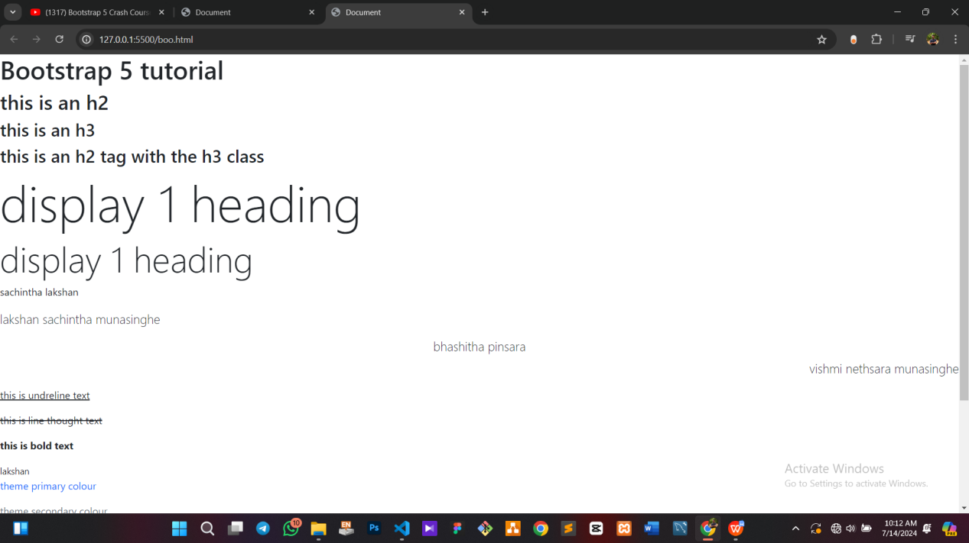

Buttons

<!DOCTYPE html>

<html lang="en">

<head>

    <meta charset="UTF-8">

    <meta name="viewport" content="width=device-width, initial-scale=1.0">

    <title>Document</title>

</head>

<link href="https://cdn.jsdelivr.net/npm/bootstrap@5.3.3/dist/css/bootstrap.min.css" rel="stylesheet"

    integrity="sha384-QWTKZyjpPEjISv5WaRU9OFeRpok6YctnYmDr5pNlyT2bRjXh0JMhjY6hW+ALEwIH" crossorigin="anonymous">

<body>

    <script src="https://cdn.jsdelivr.net/npm/bootstrap@5.3.3/dist/js/bootstrap.bundle.min.js"

integrity="sha384-YvpcrYf0tY3lHB60NNkmXc5s9fDVZLESaAA55NDzOxhy9GkcIdslK1eN7N6jIeHz" crossorigin="anonymous"></script>

<!--basic buttons-->

<h2>Buttons</h2>

<button class="btn btn-primary">primary class</button>

<button class="btn btn-secondary">secondary class</button>

<!--anchor tags as buttons-->

<h2>Links as buttons</h2>

<a href="#" class="btn btn-info">info anchor tag</a>

<a href="#" class="btn btn-success">success anchor tag</a>

<!--button sizes-->

<h2>Button sizes</h2>

<button class="btn btn-lg btn-danger">large danger button</button>

<button class="btn btn-sm btn-warning">small warning button</button>

<!--Outline styled-->

<h2>Butoon groups</h2>

<button class="btn btn-outline-primary">outlined primary button</button>

<button class="btn btn-outline-secondary btn-lg">large outlined secondary button</button>

<!--button groups-->

<div class="btn-group">

    <a href="#" class="btn btn-primary">button 1</a>

    <a href="#" class="btn btn-warning">button 2</a>

    <a href="#" class="btn btn-success">button 3</a>

</div>

</body>

</html>

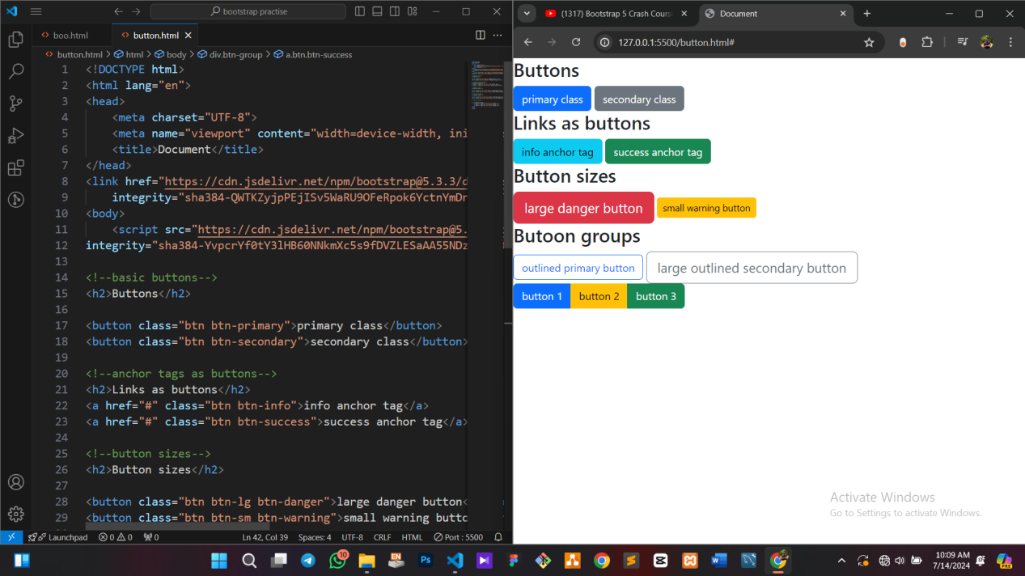

Utility Clases

<!DOCTYPE html>

<html lang="en">

<head>

    <meta charset="UTF-8">

    <meta name="viewport" content="width=device-width, initial-scale=1.0">

    <title>Document</title>

    <link href="https://cdn.jsdelivr.net/npm/bootstrap@5.3.3/dist/css/bootstrap.min.css" rel="stylesheet"

    integrity="sha384-QWTKZyjpPEjISv5WaRU9OFeRpok6YctnYmDr5pNlyT2bRjXh0JMhjY6hW+ALEwIH" crossorigin="anonymous">

</head>

<body>

    <script src="https://cdn.jsdelivr.net/npm/bootstrap@5.3.3/dist/js/bootstrap.bundle.min.js"

    integrity="sha384-YvpcrYf0tY3lHB60NNkmXc5s9fDVZLESaAA55NDzOxhy9GkcIdslK1eN7N6jIeHz" crossorigin="anonymous"></script>

    <!--margin and padding-->

      <div class="bg-primary m-1 p-1">small margin and padding</div>

      <div class="bg-primary m-5 p-5">large margin and padding</div>

      <div class="bg-primary my-3 px-10">margin in y direction,padding in x direction </div>

      <div class="bg-primary mt-3 mb-4 ms-5 me-1 pt-4 pe-2 pb-1">m & p for each direction</div>

    <!--border-->

      <div class="m-3 p-3 border">default border</div>

      <div class="m-3 p-3 border-top border">individual borders</div>

      <div class="m-3 p-3 border-start border-success">border success color at start</div>

      <div class="m-3 p-3 border-start,danger.border-56"></div>

      <div class="m-3 p-3 border-start border-danger border-5">thicker border</div>

      <div class="m-3 p-3 rounded border border-5">rounded corner</div>

      <div class="m-3 p-3 rounded-pill border border-5">rounded pill corner</div>

    <!--box shadow-->

      <div class="m-3 p-3 shadow-sm">element with small box shadow</div>

      <div class="m-3 p-3 shadow-lg">element with larger box shadow</div>

    <!--font weight-->

      <p class="fw-bold">bold text</p>

      <p class="fw-bolder">bolder text</p>

      <p>normal text</p>

      <p class="fw-light">light text</p>

      <p class="fw-italic">italic text</p>

      <p class="fst-italic fw-light">italic light text</p>

    </body>

</html>

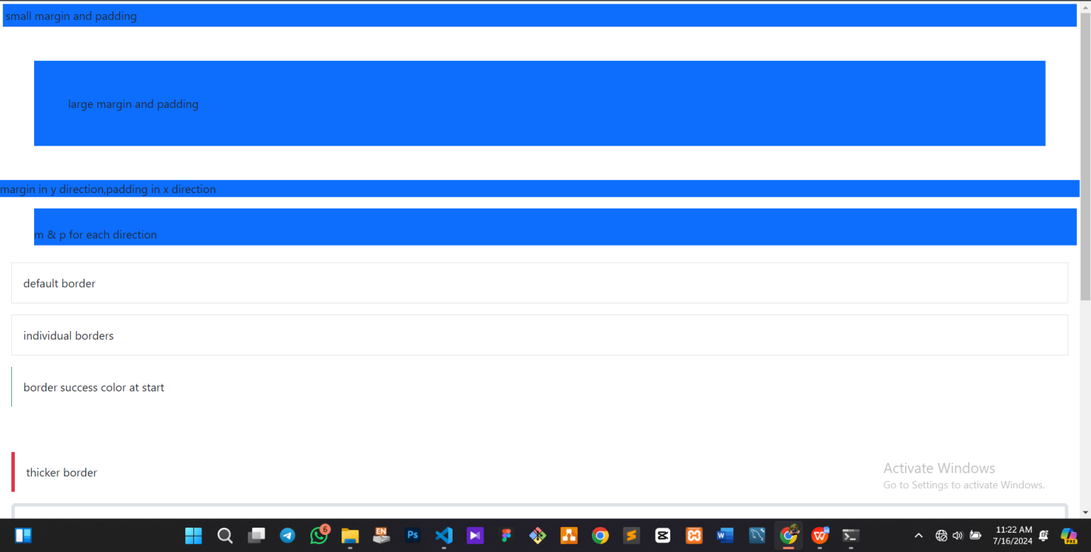

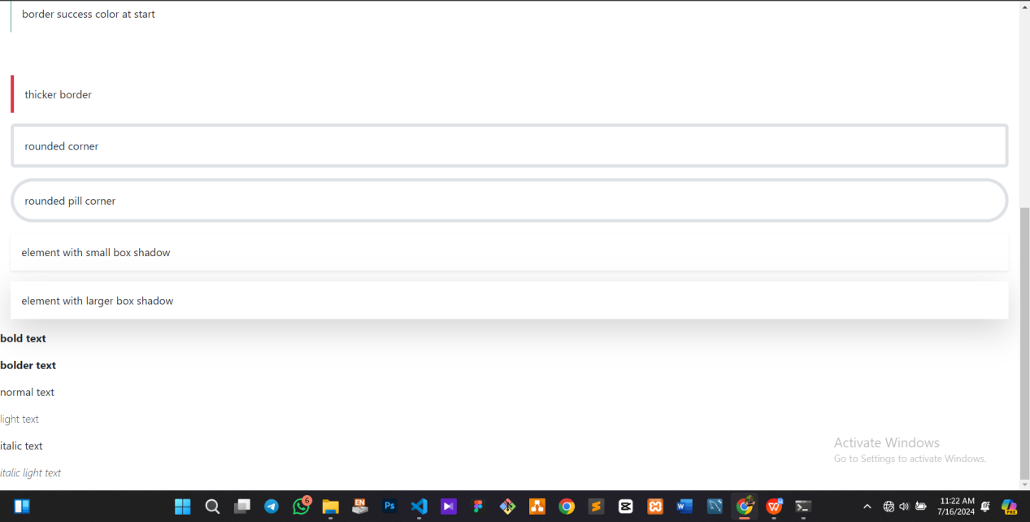

Container

<!DOCTYPE html>

<html lang="en">

<head>

    <meta charset="UTF-8">

    <meta name="viewport" content="width=device-width, initial-scale=1.0">

    <title>Document</title>

    <link href="https://cdn.jsdelivr.net/npm/bootstrap@5.3.3/dist/css/bootstrap.min.css" rel="stylesheet"

    integrity="sha384-QWTKZyjpPEjISv5WaRU9OFeRpok6YctnYmDr5pNlyT2bRjXh0JMhjY6hW+ALEwIH" crossorigin="anonymous">

</head>

<body>

    <div class="container my-5">

        <h2>normal container</h2>

        <p>my name is sachintha lakshan munasinghe and i am from ambalantota<br>

        lakshan sachintha rajpaaksha lakshan sachintha lakshan sachintha</p>

    </div>

    <div class="container-fluid">

        <h2>fluid container</h2>

        <p>Lorem ipsum dolor sit amet consectetur adipisicing elit. Aliquid fugiat debitis aspernatur, natus praesentium atque magni blanditiis vitae porro nisi perspiciatis cupiditate adipisci iste corporis quia est labore aut numquam.</p>

    </div>

    <div class="container-lg my-5">

        <h2>100% width util lg screens container</h2>

        <p>Lorem ipsum dolor sit amet consectetur adipisicing elit. Tenetur corporis laudantium fugiat quis <br>

            autem rerum sed, repellendus, dolorem, quasi vitae distinctio velit voluptate incidunt adipisci cum

            voluptates iusto? Dolor, quia.</p>

    </div>

    <div class="container-xl my-5">

        <h2>100% width util screens,then container</h2>

        <p>Lorem ipsum dolor sit amet consectetur adipisicing elit. Suscipit quos quisquam adipisci, rerum ad <br>

            saepe asperiores officia cum, neque nobis consequatur perspiciatis distinctio illo unde deleniti, ab ex

            inventore aliquid!</p>

    </div>

    <script src="https://cdn.jsdelivr.net/npm/bootstrap@5.3.3/dist/js/bootstrap.bundle.min.js"

    integrity="sha384-YvpcrYf0tY3lHB60NNkmXc5s9fDVZLESaAA55NDzOxhy9GkcIdslK1eN7N6jIeHz" crossorigin="anonymous"></script>

</body>

</html>

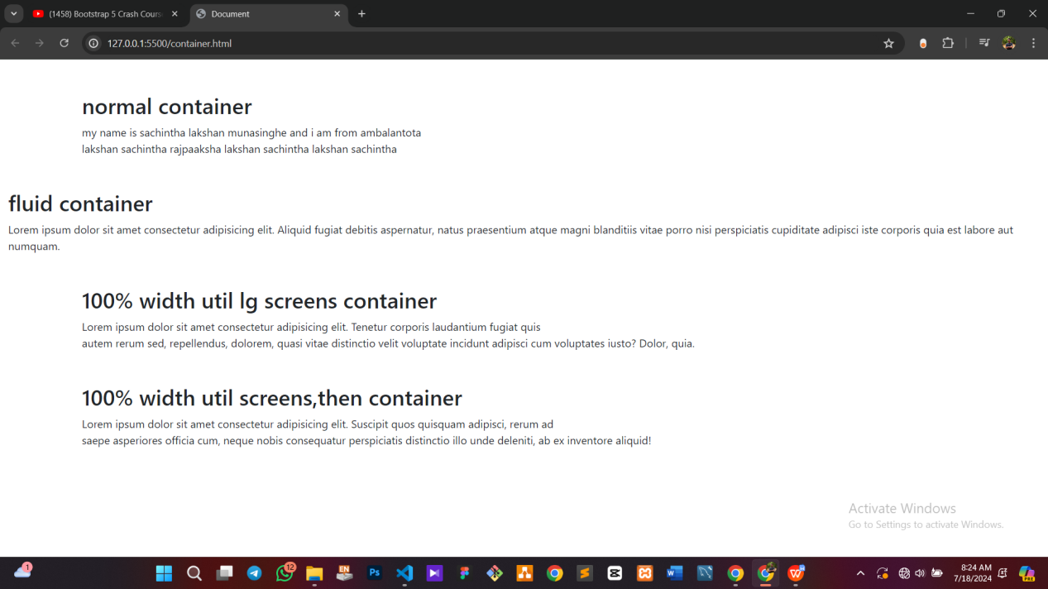

Grid layerout -1

<!DOCTYPE html>

<html lang="en">

<head>

    <meta charset="UTF-8">

    <meta name="viewport" content="width=device-width, initial-scale=1.0">

    <title>Document</title>

    <link href="https://cdn.jsdelivr.net/npm/bootstrap@5.3.3/dist/css/bootstrap.min.css" rel="stylesheet"

    integrity="sha384-QWTKZyjpPEjISv5WaRU9OFeRpok6YctnYmDr5pNlyT2bRjXh0JMhjY6hW+ALEwIH" crossorigin="anonymous">

</head>

<body>

<div class="container-lg my-5">

    <h2>basic grid</h2>

    <div class="row">

        <div class="col">

            <div class="p-5 bg-primary text-light">col 1</div>

        </div>

        <div class="col">

            <div class="p-5 bg-primary text-light">col 2</div>

        </div>

        <div class="col">

            <div class="p-5 bg-primary text-light">col 3</div>

        </div>

        <div class="col">

            <div class="p-5 bg-primary text-light">col 4</div>

        </div>

        <div class="col">

            <div class="p-5 bg-primary text-light">col 5</div>

        </div>

    </div>

</div>

<div class="container-lg my-5">

    <h2>colmn width</h2>

    <div class="row">

        <div class="col-3">

            <div class="p-5 bg-primary text-light">col 1</div>

        </div>

        <div class="col-5">

            <div class="p-5 bg-primary text-light">col 2</div>

        </div>

        <div class="col-4">

            <div class="p-5 bg-primary text-light">col 3</div>

        </div>

        <div class="col-3">

            <div class="p-5 bg-primary text-light">col 4</div>

        </div>

        <div class="col-2">

            <div class="p-5 bg-primary text-light">col 5</div>

        </div>

    </div>

</div>

<div class="container-lg my-5">

    <h2>responsive columnn width</h2>

    <div class="row">

        <div class="col-sm-4 col-lg-6">

            <div class="p-5 bg-primary text-light">col 1</div>

        </div>

        <div class="col-sm-4 col-lg-3">

            <div class="p-5 bg-primary text-light">col 2</div>

        </div>

        <div class="col-sm-4 col-lg-3">

            <div class="p-5 bg-primary text-light">col 3</div>

        </div>

    </div>

</div>

<div class="divcontainer-lg my-5">

    <h2>justifying colummns</h2>

    <div class="row justify-content-between"><!--start / end / center-->

        <div class="col-md-3">

            <div class="p-5 bg-primary text-light">col 1</div>

        </div>

        <div class="col-md-3">

            <div class="p-5 bg-primary text-light">col 2</div>

        </div>

        <div class="col-md-3">

            <div class="p-5 bg-primary text-light">col 3</div>

        </div>

    </div>

</div>

<script src="https://cdn.jsdelivr.net/npm/bootstrap@5.3.3/dist/js/bootstrap.bundle.min.js"

integrity="sha384-YvpcrYf0tY3lHB60NNkmXc5s9fDVZLESaAA55NDzOxhy9GkcIdslK1eN7N6jIeHz" crossorigin="anonymous"></script>

</body>

</html>

